Easy read summary: Avoidable deaths in adults with learning disabilities

 | We looked at the different health problems that adults with learning disabilities died from in Scotland.
 | The research showed that adults with learning disabilities were much more likely to die earlier than adults without learning disabilities.
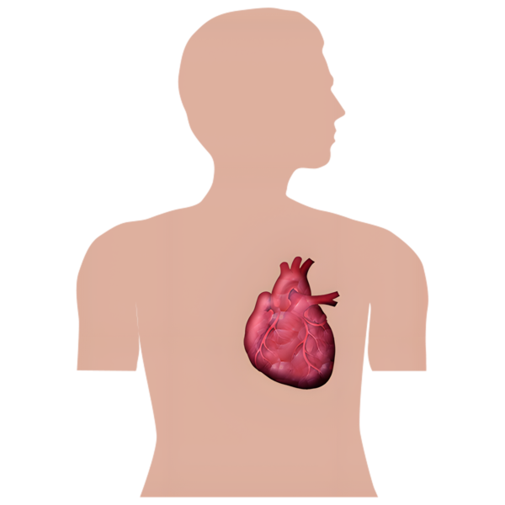 | We found that people with learning disabilities were much more likely to die from conditions such as heart disease or epilepsy.
 | We found that some people with learning disabilities were more likely to die from conditions that could have been treated.
 | Treatable conditions can be helped with medicine and support.
 | An example of a treatable condition is heart disease.
 | We found that some adults with learning disabilities die much younger than adults who do not have learning disabilities.
   | This tells us that some young adults with learning disabilities have more chance of dying from conditions that could have been treated with medicine.
 | There needs to be better care and treatment for people with learning disabilities.
 | Better care and treatment will mean that conditions are found sooner and treated with the right medicine.
 | This will help to reduce the number of people with learning disabilities dying from treatable conditions.

For more information about this research, please email us via sldo-info@glasgow.ac.uk


